**Writing Function Rules Name:____________________**

**Scenario 1: Minecraft Block Building:**In Minecraft, you're building a tower. You start with a base of 20 blocks and add 15 blocks to the height each day. Write a function rule for the height of the tower h after d days. How tall will the tower be after 7 days?

**Linear or Nonlinear:**

**Function rule:**

**Height after 7 days:**

**Scenario 2: Pokémon Training:**In Pokémon, your Pikachu gains 25 XP points for each battle it wins. It starts with 100 XP. Write a function rule for Pikachu's total XP after w wins. How much XP will Pikachu have after 12 wins?

**Linear or Nonlinear:**

**Function rule:**

**XP after 12 wins:**

**Scenario 3: Web-Shooter Fluid Production:**In "Spider-Man: No Way Home," Peter Parker starts his adventure with a full web-shooter containing 1000 ml of fluid. As he swings through the city and fights villains, he uses approximately 50 ml of web fluid every hour. Write a function rule for the amount of web-shooter fluid w Peter has remaining after h hours of crime-fighting. How long will Peter’s web fluid last before he runs out completely?

**Linear or Nonlinear:**

**Function rule:   
  
 Time when fluid runs out:**

**Scenario 4: Demogorgon Growth:**In Stranger Things, the size of a baby Demogorgon increases rapidly. Dustin notices that the creature's length (in inches) can be modeled by squaring the number of days since it hatched, plus its initial size of 3 inches. Write a function rule for the Demogorgon's length l after d days. How long will the Demogorgon be after 5 days?

**Linear or Nonlinear:**

**Function rule:**

**Length after 5 days:**

**Scenario 5: Minion Multiplication Mayhem**Gru's lab has developed a new Minion Multiplication Machine. It starts with 1 minion and triples the number of minions every hour. Write a function rule for the number of minions m after h hours. How many minions will there be after 5 hours?

**Linear or Nonlinear:**

**Function rule:**

**Minions after 5 hours:**

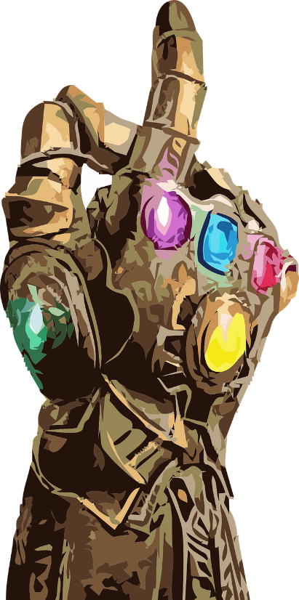**Scenario 6: Avengers Infinity War:**Thanos collects Infinity Stones. The power of his gauntlet doubles with each stone he adds, starting with a base power of 10. Write a function rule for the gauntlet's power p when Thanos has s stones. What's the power when he has all 6 stones?

**Linear or Nonlinear:**

**Function rule:**

**Power with 6 stones:**